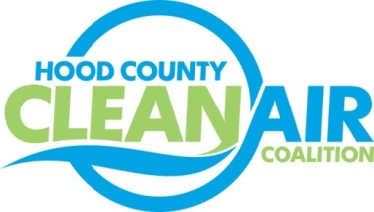
Meeting: Tuesday, September 1, 2015
Neely House
304 East Rucker Street, Granbury, Texas 76048
8:30-10:00 a.m.

Agenda

- Call Meeting to Order
- EPA Updates – Carrie Paige
- Regional Updates – Michelle McKenzie
  - Air Quality Funding Opportunities for Vehicles
  - National Drive Electric Week, September 19
  - NCTCOG Starting Development of the Mobility 2040 Plan
  - Revised Ozone Standard Expected to be Announced October 1, 2015
- Local Updates – Michelle McKenzie
  - Review of August Meeting Summary
  - Review of Projects
    - Monthly Budget Review for July
    - Status of Projects
      - Bike Equipment
      - Propane Refueling Stations
      - TV Programming
      - Additional Radio Advertising
      - FY 16/17 PGA and Contract Extension
  - Administration for the HCCAC
    - Bank Account
    - Record Book
  - Reports
    - Ozone Update through August
    - Ozone Advance/ Nonattainment Areas Meeting
5.) Discussion
6.) Adjourn

